**AEE 342: Aerodynamics, Project 1c – Analysis of Symmetric Airfoils**

**Submitted: 02/20/15**

In the study of computational fluid dynamics, there are numerous ways to model the interaction between a physical surface and the flow being modelled. In relatively simple cases, point singularities can be modelled with certain strengths in order to either ‘attract’ or ‘repel’ the flow. The strengths of these points are constrained by the system’s required geometry and flow conditions. In the current investigation, a similar method is adopted but with sources defined over finite lengths on the surface of an airfoil. These sources are known as ‘panels’ and the general name for the method is the source panel method. Here, the position and orientation of the panels are constrained by the airfoil’s geometry and the strengths are constrained by both the geometry and the flow conditions. In this part of the investigation, particular attention is paid to the process of defining the boundaries of a NACA 4-series airfoil and fitting panels to fit those boundaries. Additionally, some analysis of the airfoil’s performance is evaluated as well.

The shapes of NACA 4-series airfoils is given by a four number designation of the form . Here, is the maximum camber as a percent of chord length, is the position along the chord of maximum camber as tenths of chord length, and is the thickness as a percent of chord length. Two general categories of airfoil include those that are symmetric, and those that are asymmetric. This can be determined by the first two numbers in the airfoil designation. If and are both 0, then the airfoil is symmetric. Otherwise, it has some camber. For either case, a set of x-values must first be defined from which to plot the thickness and curvature of the particular airfoil. These can be defined well by the relation

Where can be a set of values chosen from to , so that resulting values of x are between 0 and 1. This trigonometric definition of x-values generally leads to better results than those of a linear distribution because it causes points to be plotted at a greater density near the ends of the airfoil than in the middle. This is desirable because many of the important flow interactions occur on the leading and trailing edges of the airfoil and would thus demand greater precision. A lower order of precision is generally acceptable near the middle of the airfoil. Next, the camber line must be defined. This is given for a cambered NACA 4-series airfoil as the piecewise function

In the case of a symmetric airfoil, the camber line coincides with the chord exactly, and is thus simply a straight line from 0 to 1 along the x-axis. Next, the NACA 4-series thickness is given by

The thickness of the airfoil is taken at an angle perpendicular to the camber, so a trigonometric transformation must be performed to find the actual locations of points on the airfoil. However, in the case of an uncambered airfoil, this is trivial since the direction of thickness lines up exactly with the Cartesian y-axis. Therefore, the locations of points on a symmetric airfoil are given by

The angle of the camber line can be found by taking the arctan of its slope, as seen in the relation

With this angle known at all points, the points on the surface of a cambered airfoil can be determined by

With these points all defined, the geometry of the problem has been fully constrained. The next step is to generate panels connecting each of the points on the airfoil’s surface to the next one in a clockwise direction. Then, by evaluating a matrix of strengths relative to each other such that the net source of the system is equal to 0, the strengths of each source panel can be determined. Using these methods, the following solutions and visualizations have been generated. Among the graphs plotted, important values such as pressure coefficients have been determined for the airfoil. These values are particularly useful because coefficients of lift and drag can ultimately be calculated by integrating these values along the surface of the airfoil, given by

For inviscid flow over an airfoil of chord length . These values can be converted to components of lift and drag by the relations

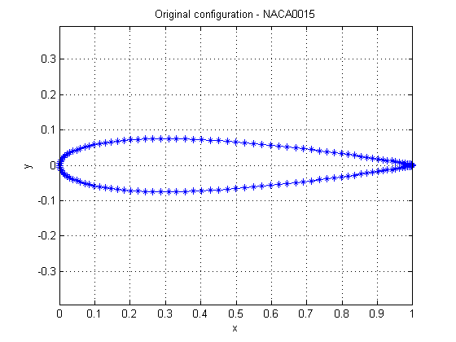In the figure shown below, the plotted geometry of a NACA 0015 airfoil can be seen. This airfoil is clearly symmetric, and must be so since its designation states that there is 0 camber. The designation also states that the thickness of the airfoil is or just .